**CSS 225 Module 2 Lab Activity – Good Programming Habits**

**Practice Pseudocode and Flowcharts:**

For the flowcharts we will be using a web app for drawing: draw.io

Write Pseudocode and draw flowcharts for the following programs:

1 – A program that prints “Hello World” to the screen.

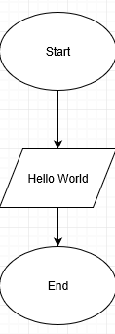

2 – A program that asks the user for their name and greets them with their name.

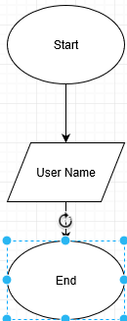

3 – A program that asks the user for a number n and gives them the possibility to choose between computing the sum and computing the product 1, ..., n.

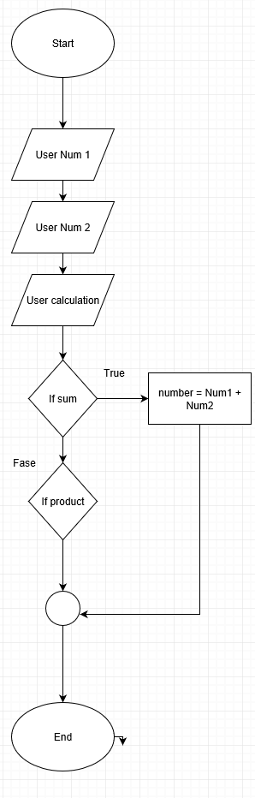

**Naming Schemes**

You are writing a new program and want to use an obvious and consistent naming scheme for each variable you will create.

4 – A program that calculates the users BMI (Body Mass Index). You will need to collect their height and weight. What would you name these input variables? What would you name the output variable?

User Height

User Weight

Body, mass, and Index

5 – A program that checks if the user for their login and password and checks it against a database. What names would you give these variables?

User Login

User password

User Check

6 – A program that automatically converts English text to Morse code and vice versa. What names would you give the variables in this program?

User English Text

User Vice Versa

**Resources**

It is important to develop a list of resources you can use to help you solve problems. Do a web search and find three sources that have not been mentioned in the slides or books.

7 – https://python-resources.blogspot.com/

8 – https://www.computerscienceonline.org/learn-python/

9 – https://codecondo.com/10-ways-to-learn-python/